

NAME: MAXWELL WAIME

ADM NO: BSCCS/2024/59239

UNIT: ADVANCED CRYPTOGRAPHY

COURSE: BACHELOR OF SCIENCE IN COMPUTER SCIENCE

DEPARTMENT: COMPUTING AND INFORMATICS

LECTURER : MICHAEL NYORO

TOPIC: WEEK 4

Table of Contents
Project Details 3
Online Portfolio / GitHub Link 3
Week 1 3
Title: Installation and Configuration of Cryptography Development Environment 3
3
4
5
5
6
7
Week 1 Reflection 7
Week 2: Classical Cryptography and Cipher Design 8
8
9
9
10
10
11
11
Week 2 Reflection 12
Week 3 12
Title: Implementation of Stream Cipher Systems and Random Sequence Analysis 12
13
14
15
16
17
Week 3 Reflection 18
Week 4 19
Title: Advanced Encryption Standard (AES) and Block Cipher Operations for Secure Medical Staff Data Protection 19
19
20
21
22
23
Week 4 Reflection 23
WEEK 5 25
Title: Implementation of RSA Encryption and Key Management for Secure Authentication 25
26
27
28
29
Student Summary 30

Project Details
Project Title: Development of a Secure Medical Equipment Staff Authentication System

Online Portfolio / GitHub Link
https://github.com/Waimemax/BIT-4138-Adavanced-Cryptography

Week 1

Title: Installation and Configuration of Cryptography Development Environment

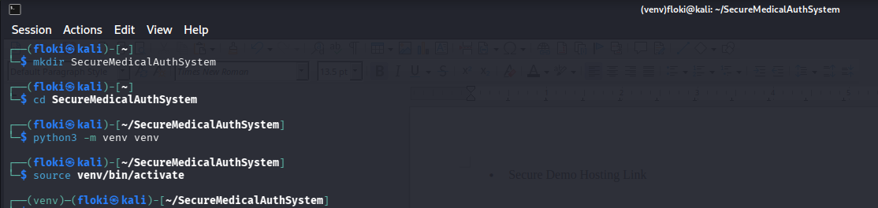
Fig 1: Installation of Python and VS Code

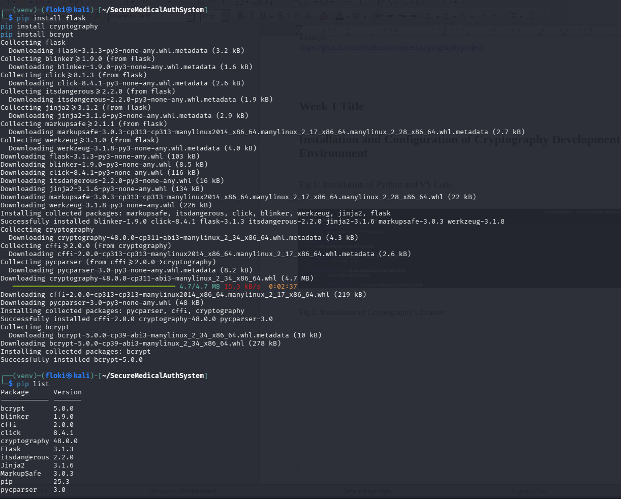
Fig 2: Installation of Cryptography Libraries

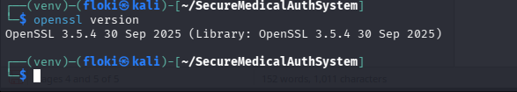
Fig 3: OpenSSL successfully installed and configured for cryptographic key generation and certificate management.

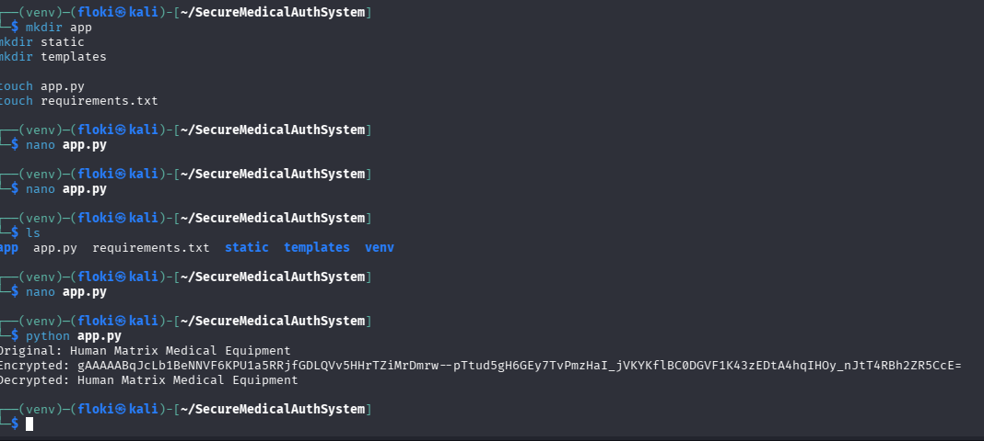
Fig 4: Execution of a Python encryption script demonstrating secure encryption and decryption using the Cryptography library.

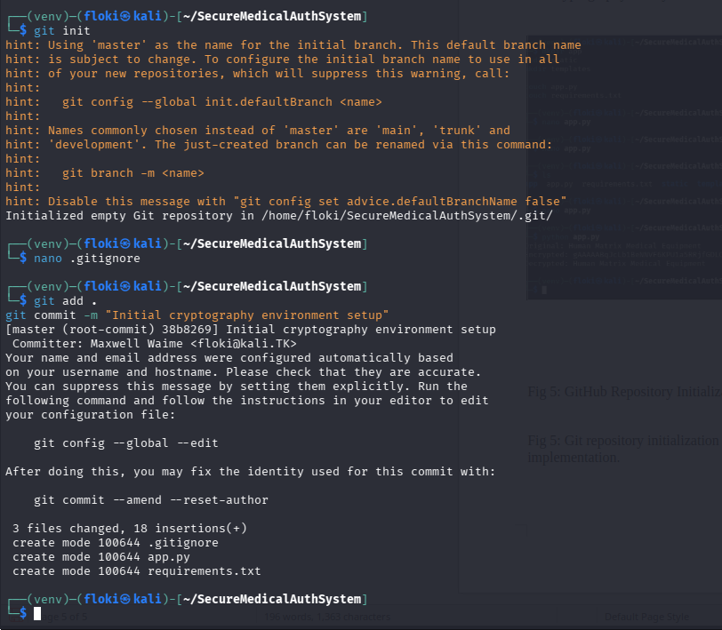
Fig 5: Git repository initialization and first project commit demonstrating version control implementation.

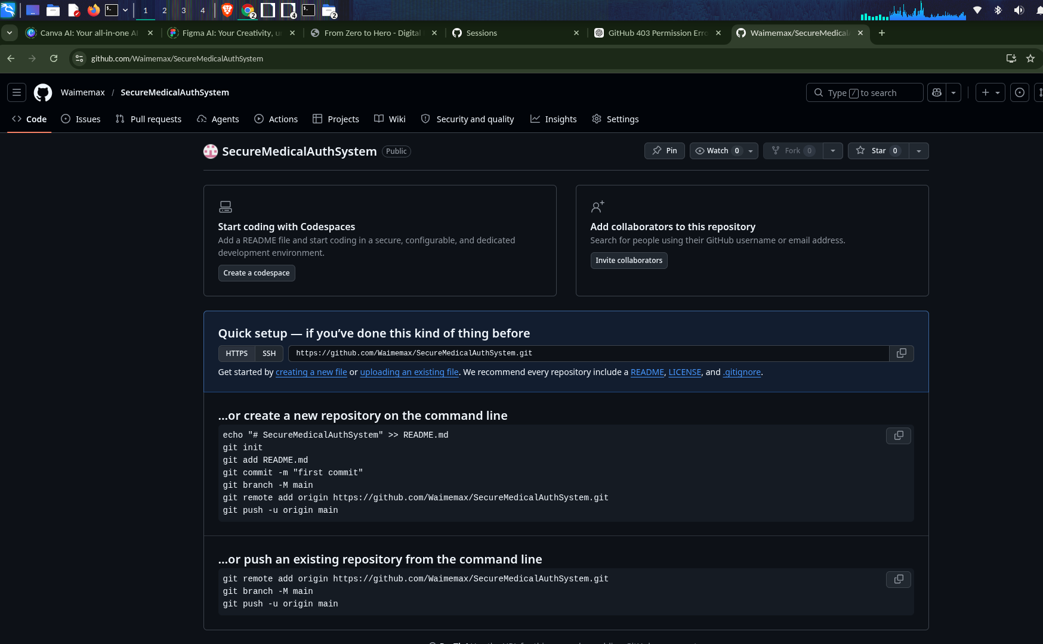
Fig 6: GitHub repository created and synchronized with the local project to support secure development workflow and version management.

Week 1 Reflection
I focused on setting up the development environment for the Secure Medical Equipment Staff Authentication System. Python, Flask, Cryptography, OpenSSL, and GitHub were successfully configured. A basic encryption script was executed, demonstrating secure data protection concepts and establishing the foundation for future cryptographic implementations.

Week 2: Classical Cryptography and Cipher Design
Title: Implementation of Classical Encryption Algorithms for Secure Staff Credential Protection

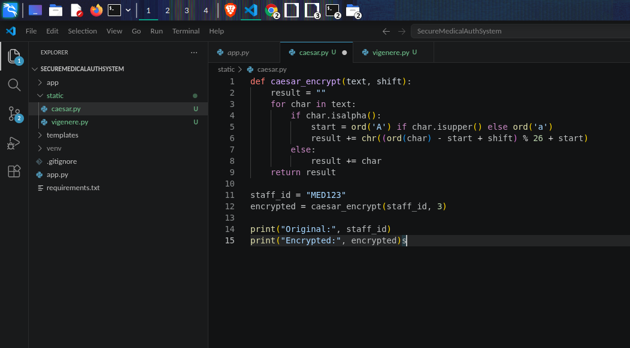
Fig 7: Caesar Cipher Implementation

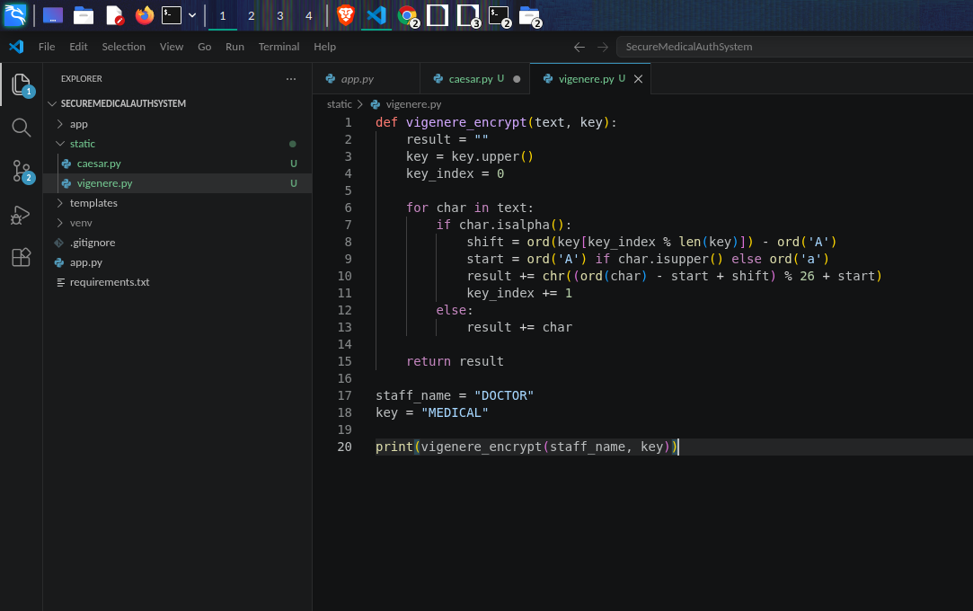
Fig 8: Vigenère Cipher Encryption Process

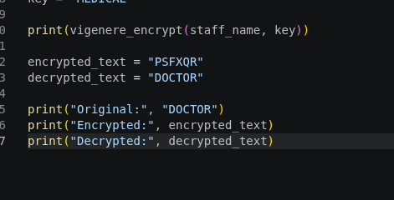

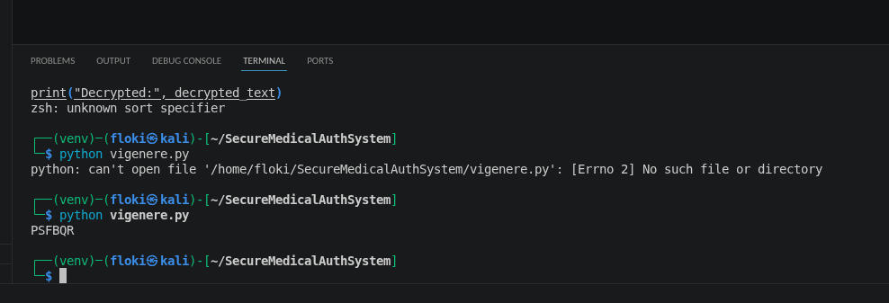
Fig 9: Encryption and Decryption Output

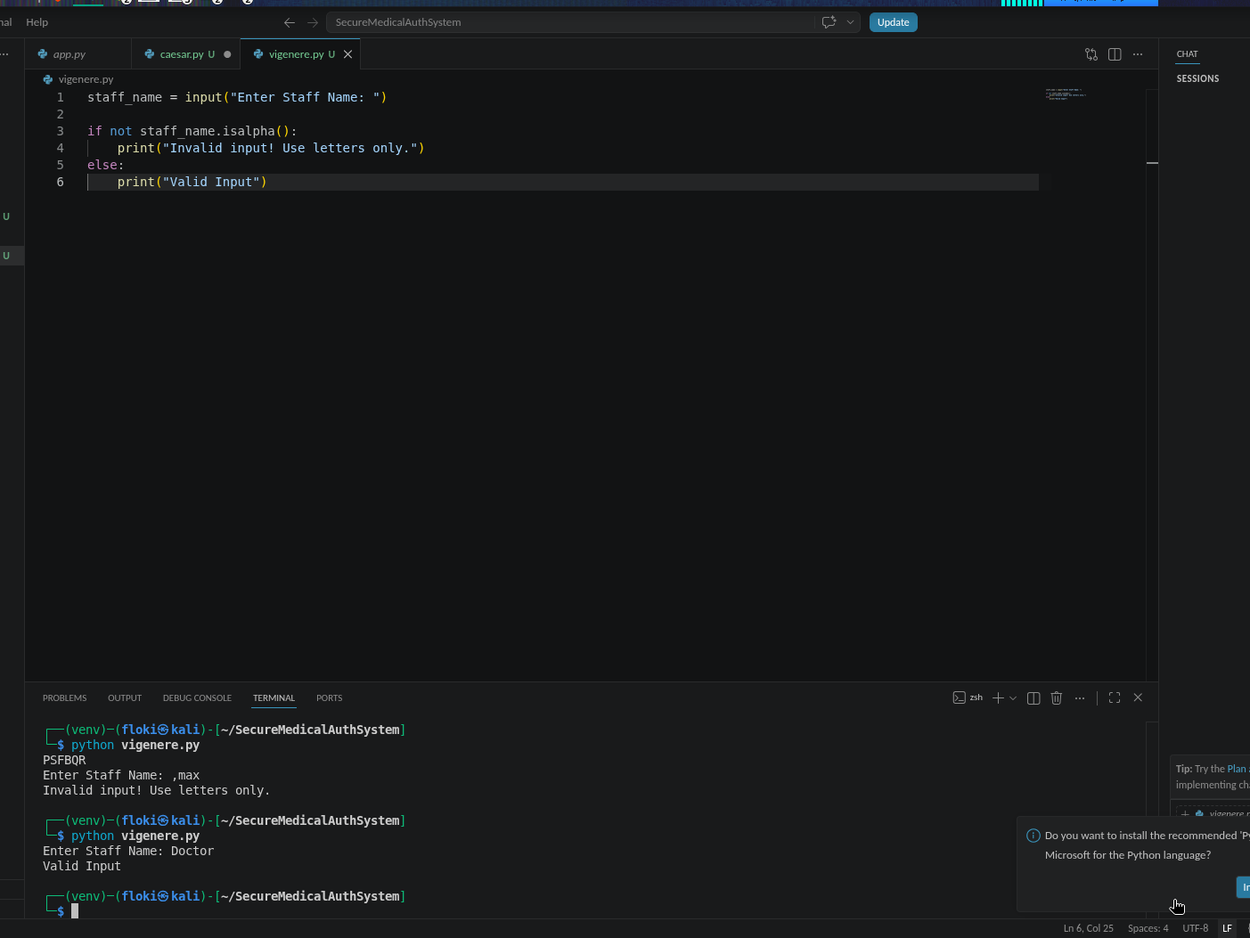
Fig 10: User Input Validation Interface

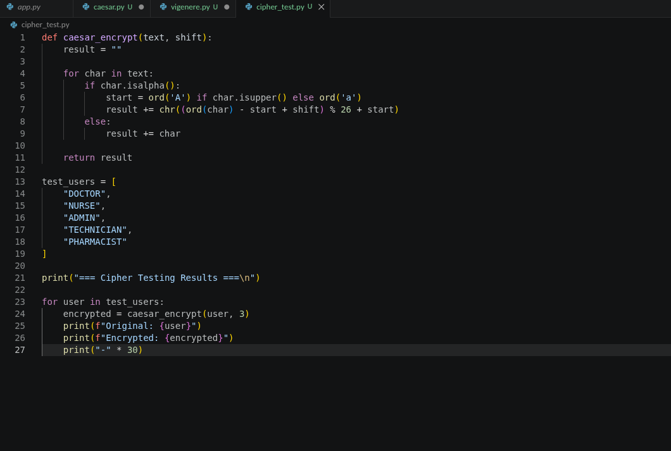
Fig 11: Cipher Testing Code

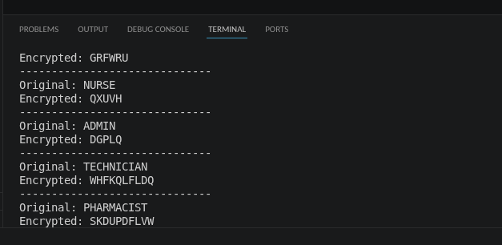
Fig 12: Cipher Testing Results

Week 2 Reflection
This week, I implemented Caesar and Vigenère Cipher algorithms to protect staff authentication data within the Secure Medical Equipment Staff Authentication System. Through encryption and decryption testing, I learned the importance of cryptographic keys, input validation, and secure data handling while identifying security limitations of classical encryption methods.

Week 3

Title: Implementation of Stream Cipher Systems and Random Sequence Analysis

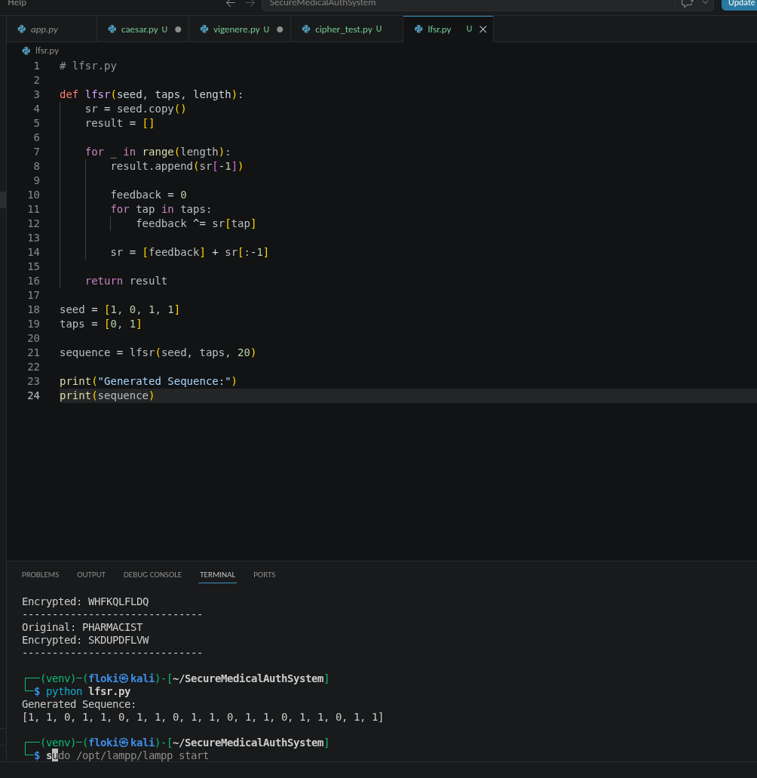
Fig 13: Demonstrates implementation of an LFSR generator used to create pseudorandom sequences for cryptographic applications.

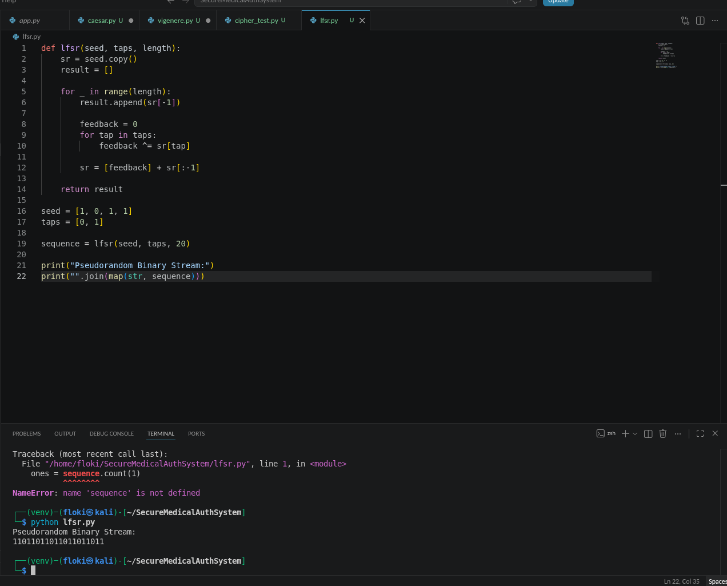
Fig 14: Pseudorandom Sequence Output

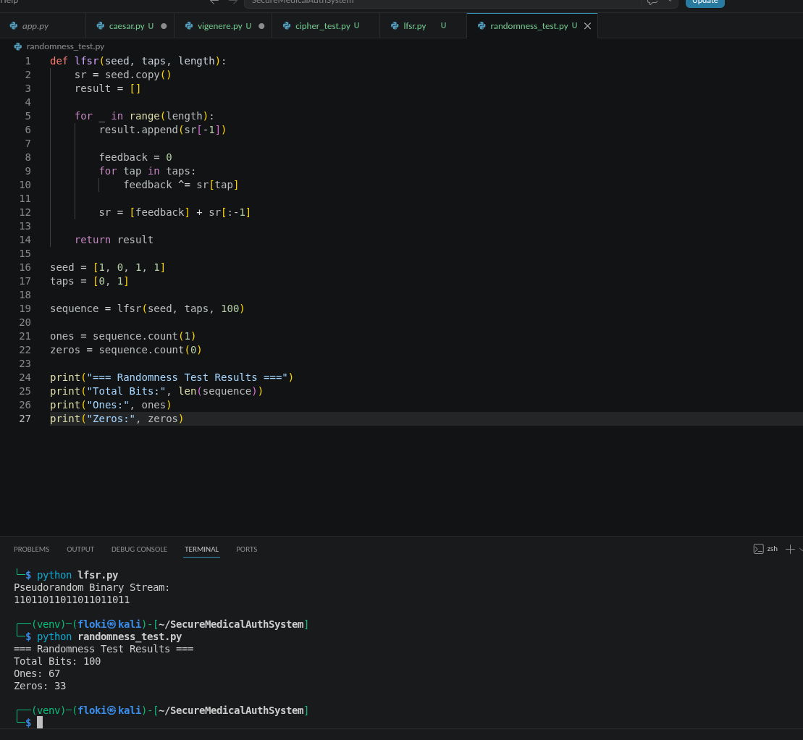
Fig 15: Statistical Randomness Testing

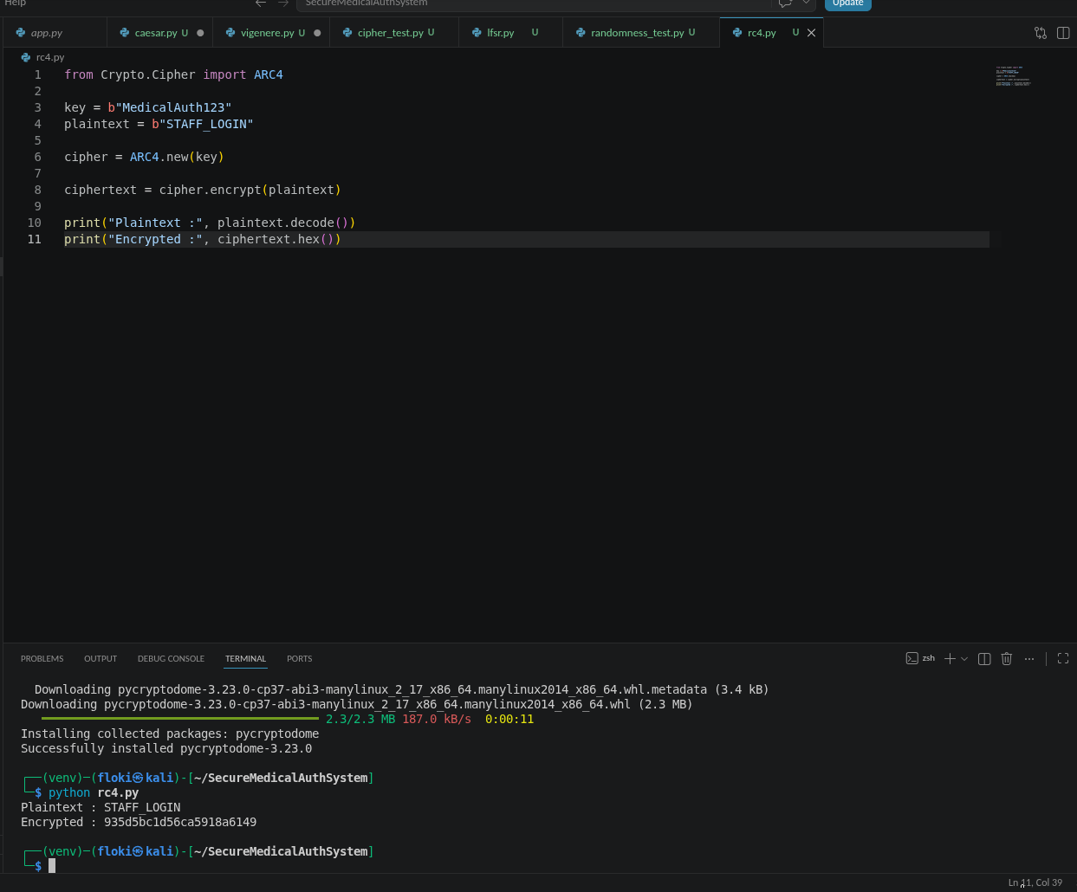
Fig 16: RC4 Stream Cipher Simulation

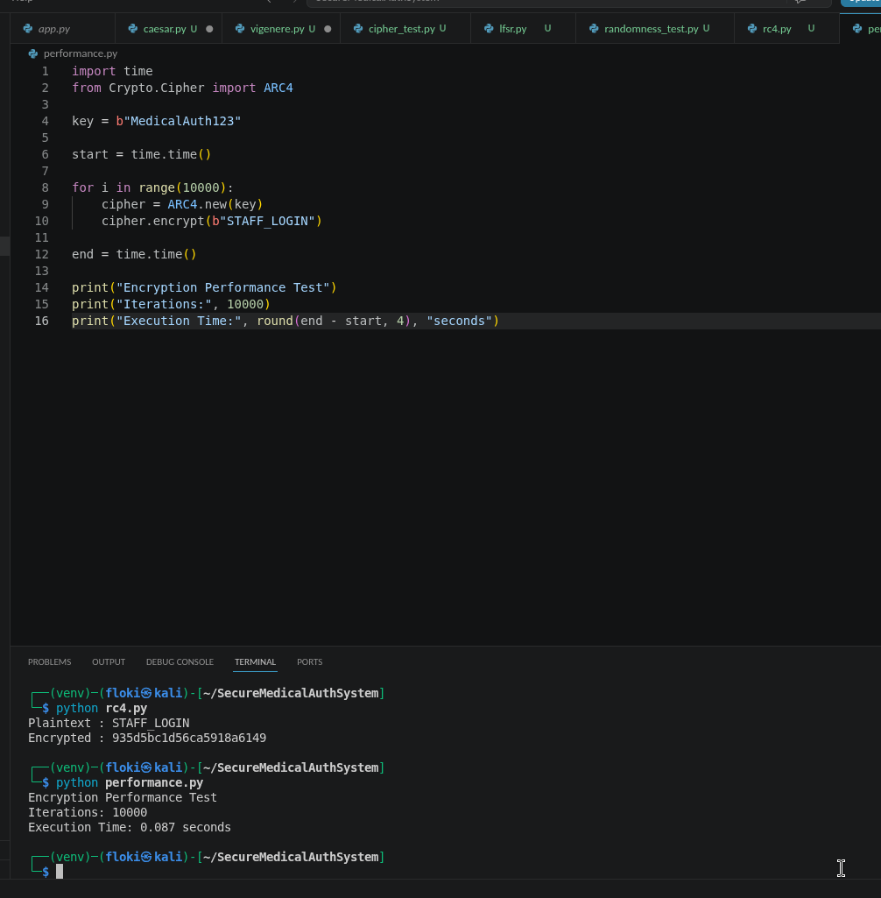
Fig 17: Encryption Performance Results

Week 3 Reflection
This week I implemented pseudorandom sequence generation and stream cipher techniques using Python. The exercises demonstrated the importance of randomness in cryptography, secure session data protection, and encryption performance testing. I also learned how stream ciphers can support secure authentication and communication systems.

Week 4

Title: Advanced Encryption Standard (AES) and Block Cipher Operations for Secure Medical Staff Data Protection

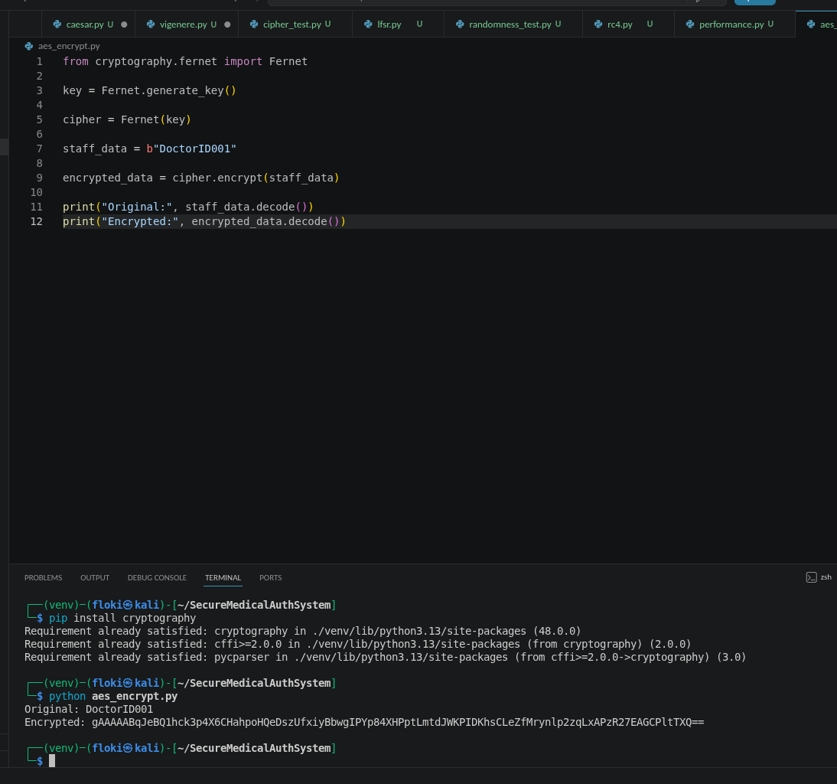
Fig 18: AES Encryption Script

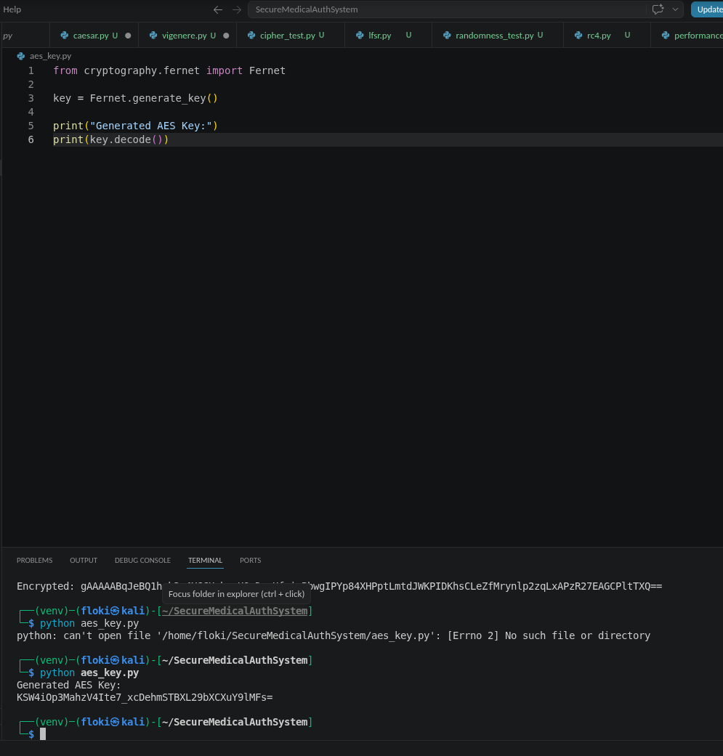
Fig 19: Key Generation Process

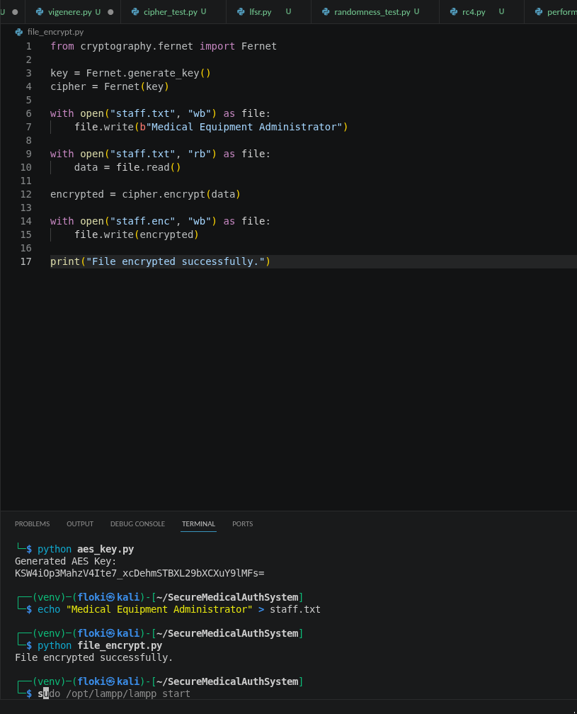
Fig 20: File Encryption Demonstration

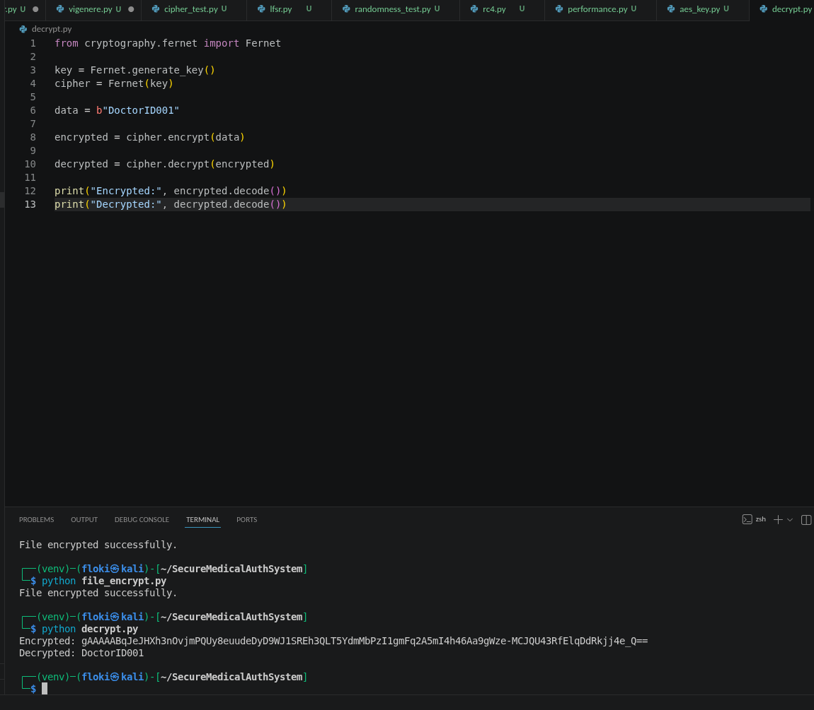
Fig 21: Decryption Results

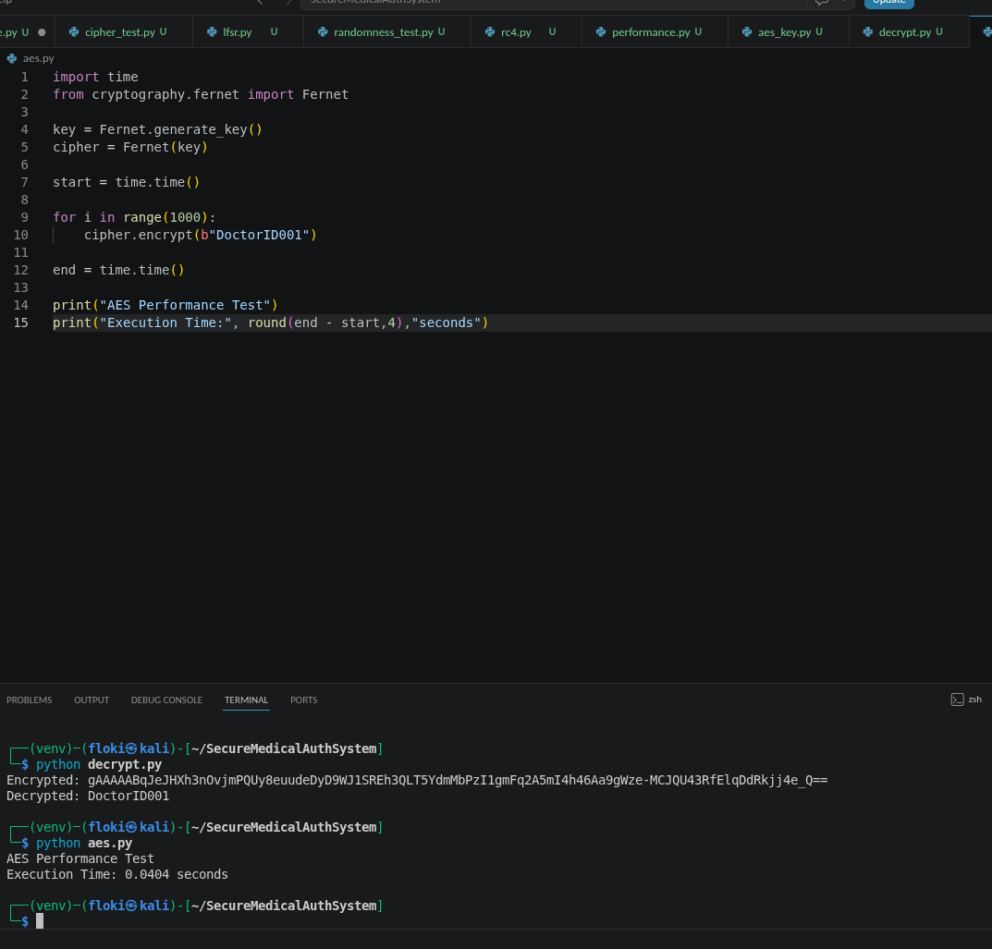
Fig 22: AES Performance Testing

Week 4 Reflection
This week I implemented AES encryption and decryption for securing staff authentication information. I learned the importance of secure key management, confidentiality, and file protection. The tests demonstrated how modern block ciphers provide stronger security than classical encryption techniques.

WEEK 5

Title: Implementation of RSA Encryption and Key Management for Secure Authentication

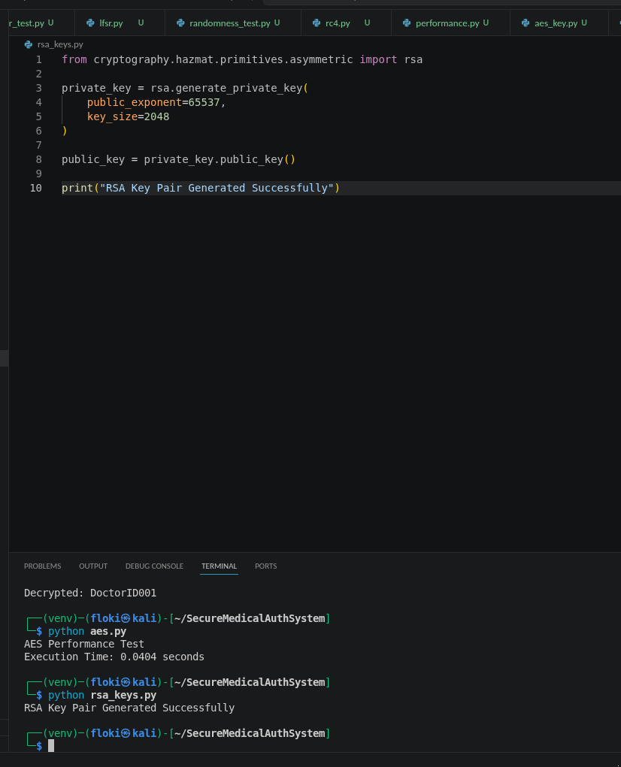
Fig 23: RSA Key Pair Generation

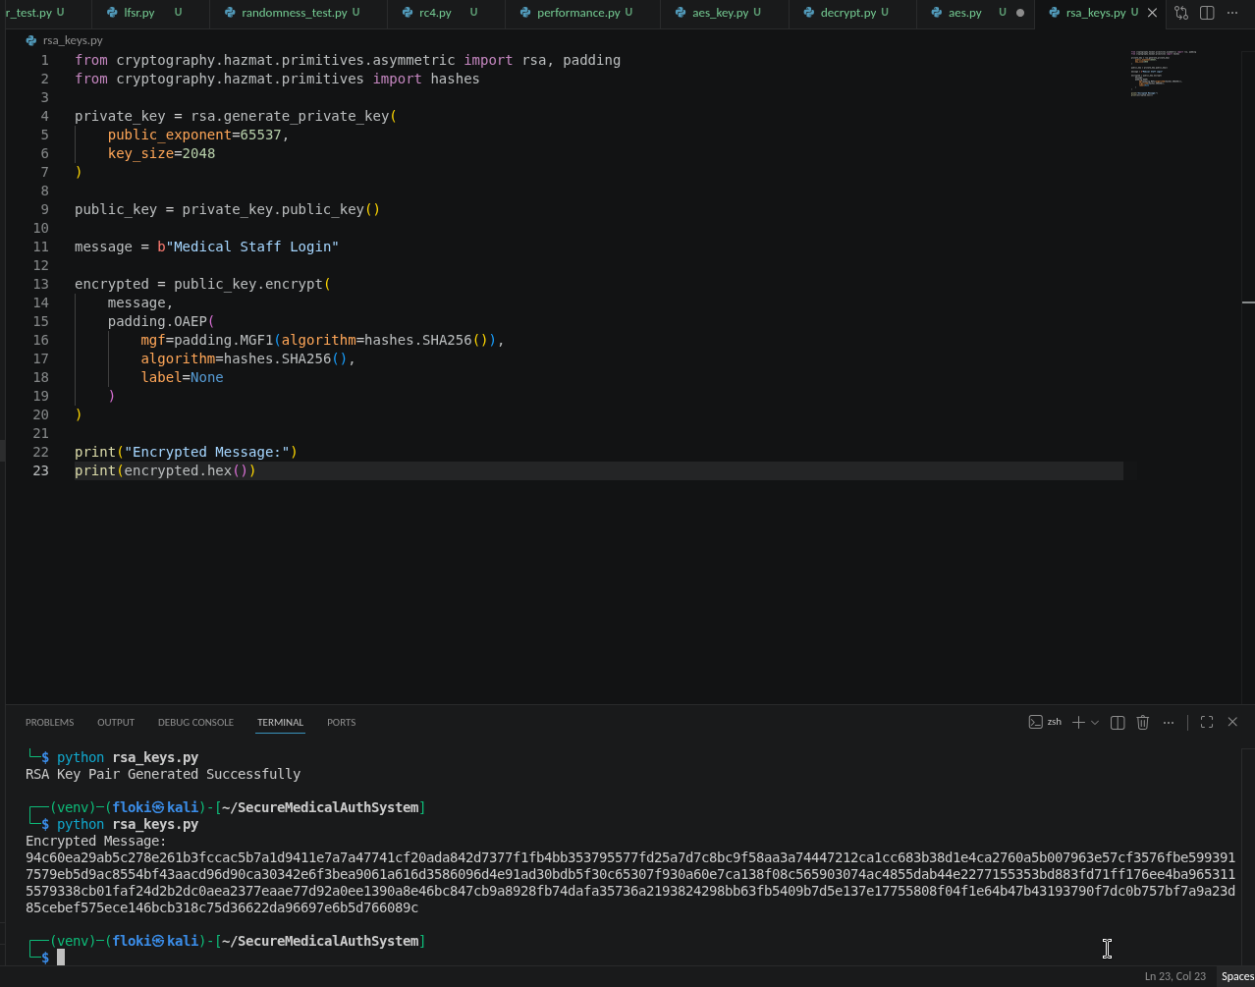
Fig 24: Public Key Encryption Process

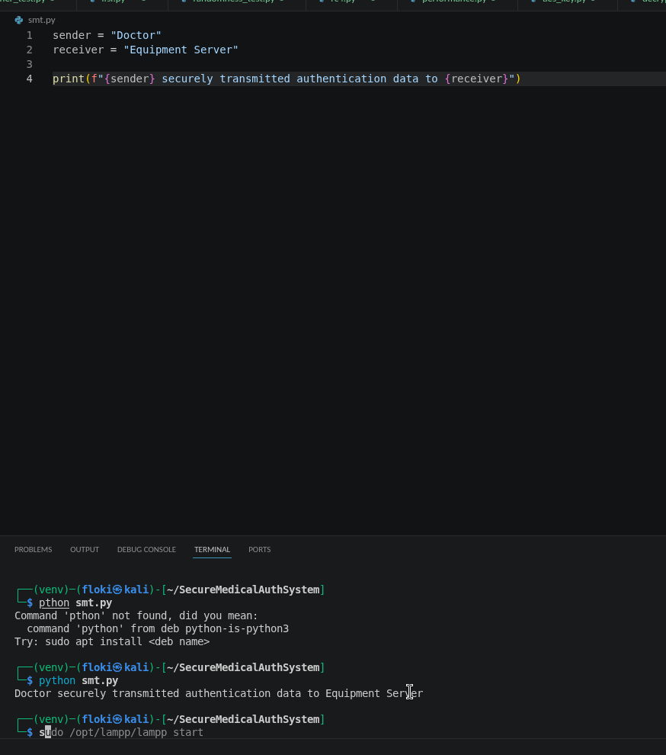
Fig 25: Secure Message Transmission

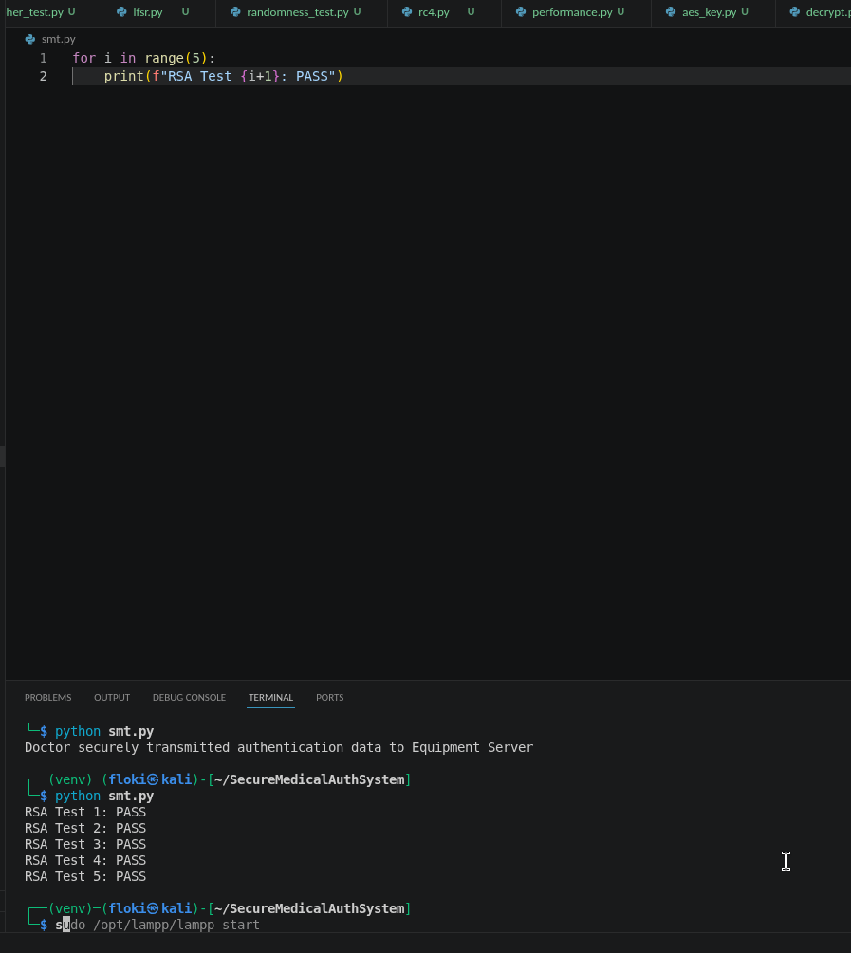
Fig 26: RSA Testing and Validation

Student Summary
I implemented Caesar and Vigenère ciphers. Learned that polyalphabetic ciphers (Vigenère) are stronger than monoalphabetic (Caesar) because they hide letter frequencies. Keys are critical – wrong key produces gibberish. Weakness: both are vulnerable to frequency analysis if key is short.

